Project Design Phase-II
Data Flow Diagram & User Stories

Date | 03 August 2026
Team ID | N/A
Project Name | ShopEZ E-Commerce Application
Maximum Marks | 4 Marks

Data Flow Diagrams:
The Context Diagram views the entire Shopez application as a single system process and illustrates its interactions with external entities.A Data Flow Diagram (DFD) is a traditional visual representation of the information flows within a system. A neat and clear DFD can depict the right amount of the system requirement graphically. It shows how data enters and leaves the system, what changes the information, and where data is stored.

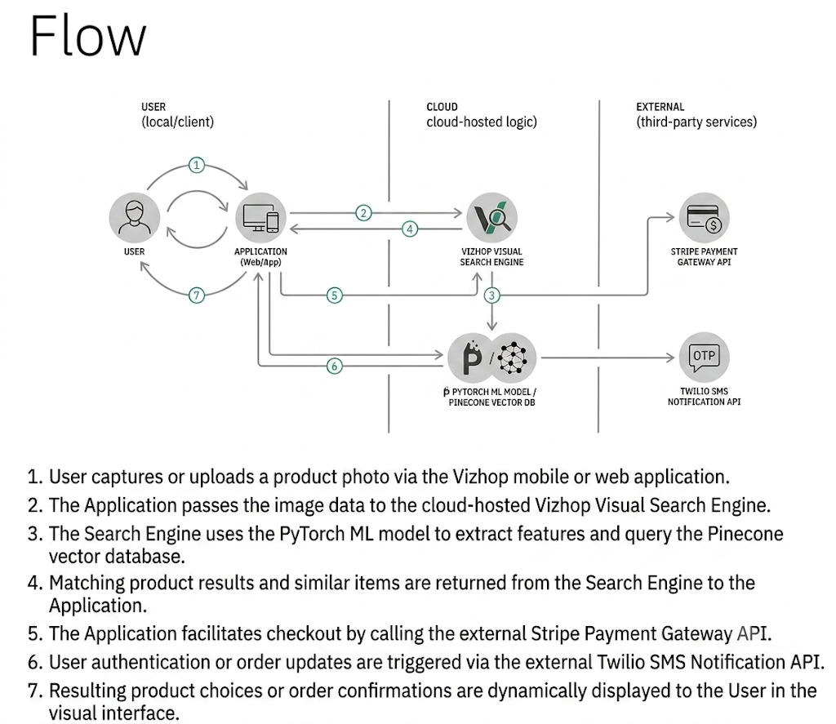

User Stories
Use the below template to list all the user stories for the product.
User Type | Functional Requirement (Epic) | User Story Number | User Story / Task | Acceptance criteria | Priority | Release
Customer (Mobile user) | Registration | USN-1 | As a user, I can register for the application by entering my email, password, and confirming my password. | I can access my account / dashboard | High | Sprint-1
 |  | USN-2 | As a user, I will receive confirmation email once I have registered for the application | I can receive confirmation email & click confirm | High | Sprint-1
 |  | USN-3 | As a user, I can register for the application through Facebook | I can register & access the dashboard with Facebook Login | Low | Sprint-2
 |  | USN-4 | As a user, I can register for the application through Gmail | I can register & access the dashboard with Google Login | Medium | Sprint-1
 | Login | USN-5 | As a user, I can log into the application by entering email & password | I can log in successfully and view my profile | High | Sprint-1
 | Visual Search | USN-6 | As a user, I can upload or take a photo to search for visually similar products. | App returns matching products within 2 seconds | High | Sprint-1
Customer (Web user) | Product Discovery | USN-7 | As a user, I can view 360° product previews and short video reviews on product pages. | Video and 360° views render smoothly without lag | Medium | Sprint-2
Customer Care Executive | Cart & Checkout | USN-8 | As a user, I can checkout quickly using 1-click payment (Stripe/Apple Pay) as a guest. | Order is placed and receipt is generated instantly | High | Sprint-1
 | Visual Search | USN-9 | As a web user, I can drag and drop an image into the search bar to find products. | Search engine processes image and displays visual matches | High | Sprint-1
 | Order Tracking | USN-10 | As a web user, I can track my active order status and delivery updates in real-time. | Live delivery map and tracking timeline are updated | Medium | Sprint-2
 | Order Support | USN-11 | As a customer care agent, I can view user order details and handle return/refund requests. | Ticket status updates to "Resolved" and refund is initiated | High | Sprint-2
Administrator | Catalog & AI Management | USN-12 | As a customer care agent, I can view user order details and handle return/refund requests. | New products immediately appear in visual search queries | High | Sprint-1

